GUVI TASK 19

MINIKUBE [ session: 19/7/24 ]

1. In this task we need to explore about minikube by installing it through official website
2. You can install it using official website link

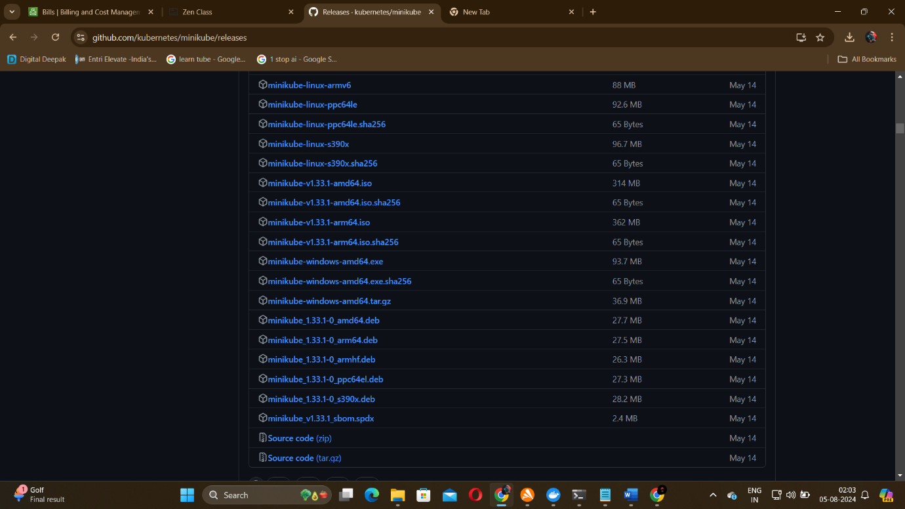

I downloaded from github releases – windows amd64

1. After downloading it copy paste the file to a separate folder in C disk. Rename the downloaded file as “minikube.exe”
2. To run this minikube we need to enable virtualization using BIOS setup. I chose different way
3. I decided to use docker instead which acts as a driver instead of enabling virtualization
4. So go to docker website and download it for windows

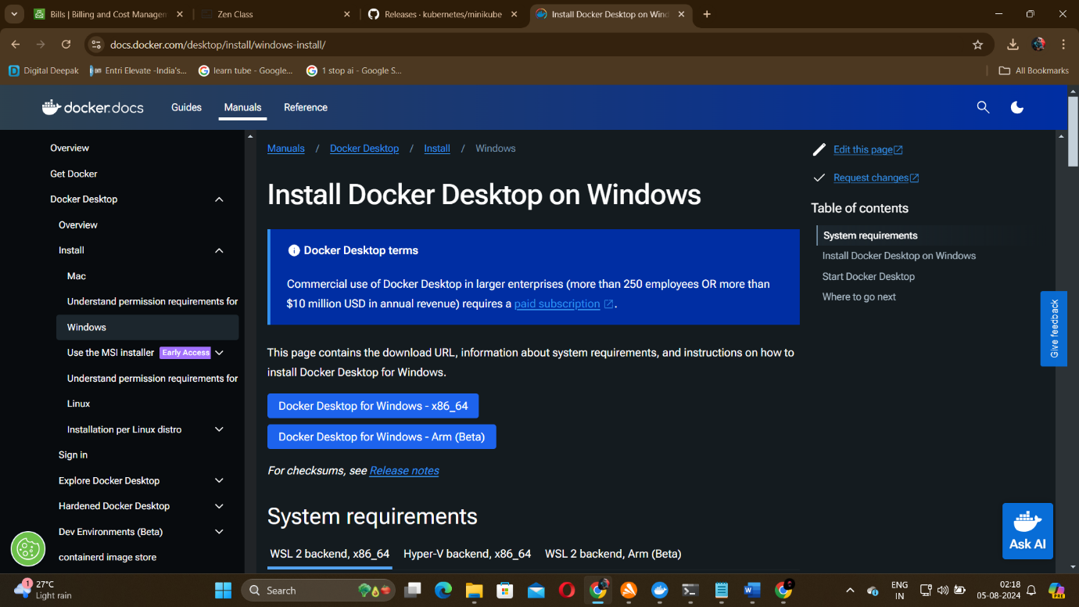

1. So after downloading this installer follow the execution steps then docker gets downloaded successfully in your desktop
2. Next open system variables and edit the path variable and add your folder path [ eg: C:\Program Files\minikube]

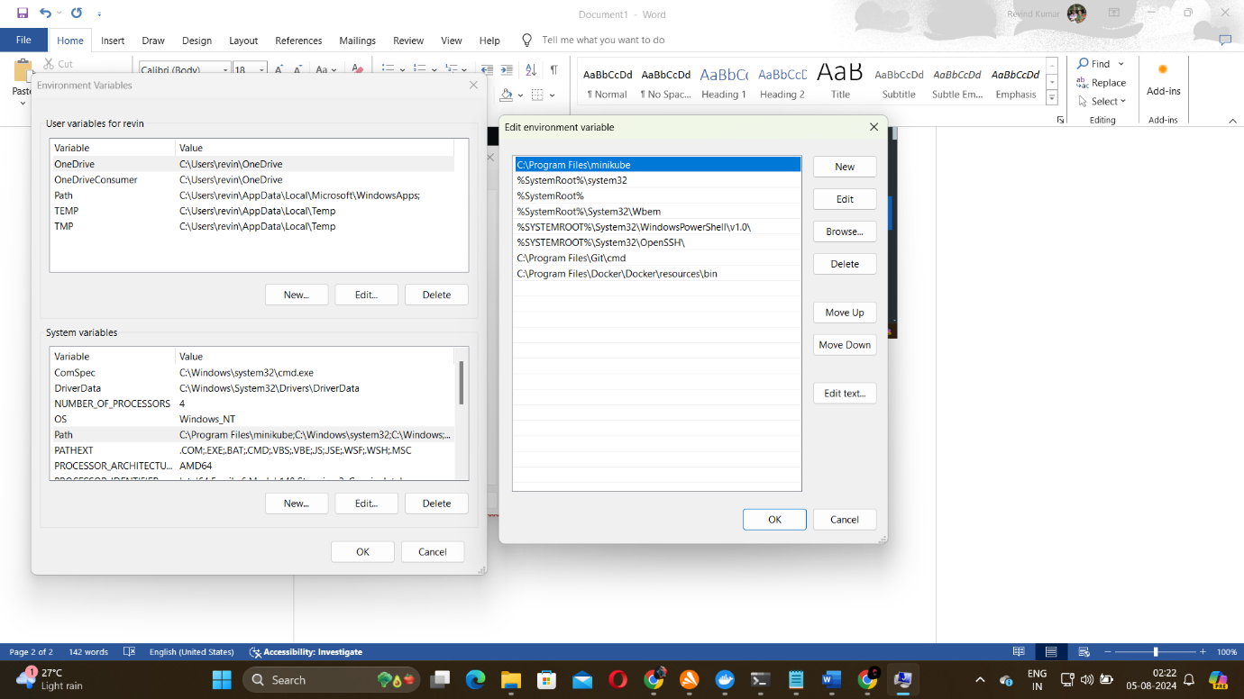

Then click ok and close it.

1. Now open either cmd or powershell it depends on your wish. I used powershell

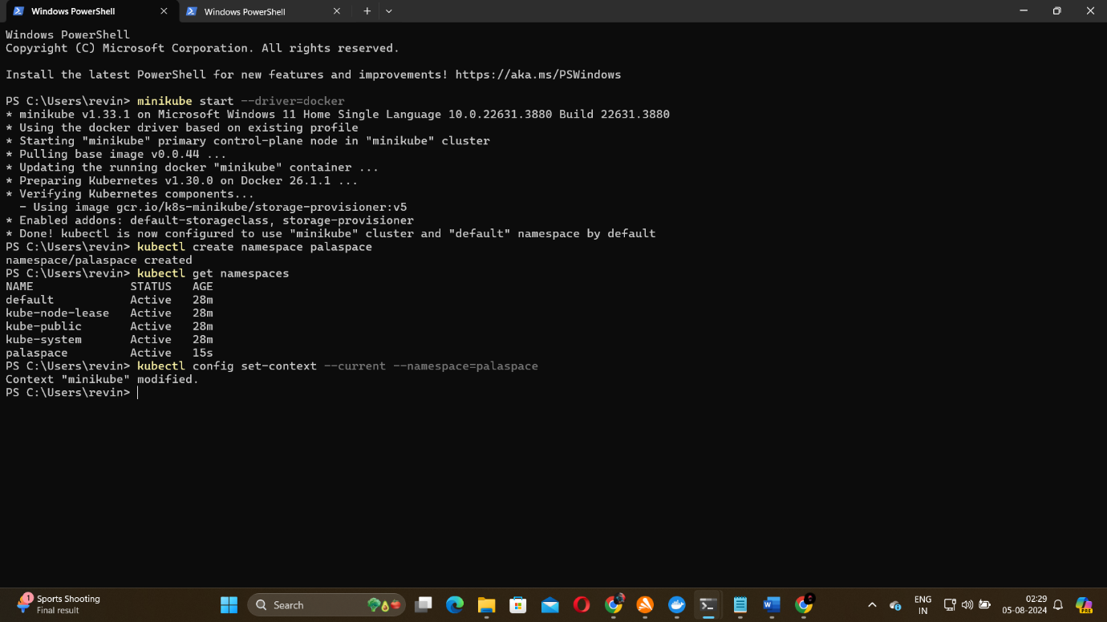

Here you can see the commands I’ve used to start minikube using docker and how to create a namespace and check other namespaces and configure to a particular cluster.

-----X-----